# Exercises: Introduction to MVC – Part III

Problems for exercises and homework for the [“C# Web Basics” course @ SoftUni](https://softuni.bg/courses/csharp-web-development-basics).

In the following exercises, you will be required to use the HTTP Server and the MVC framework you created.

**Read all** task descriptions **before you start to develop the application** for better understanding of how the application should look and feel like.

## Shouter Overview

In this exercise, we will create a web application called **Shoute**r. It would have capabilities similar to **micro blogs** (such as Twitter). Any user should be able to **register** and **log in**. When the user is logged in he should be able to **send shouts**. A shout is just a **plain text** with no more than **160 characters**. Also, he can **see the shouts** sent from all users. Furthermore, a user can **follow another user**. There should be a **section** when the user c**an see shouts only from users** who he decided to follow. The user should have capabilities of **deleting his shouts** as well as **managing followers**. The images on the exercises are just a simple example of how the page could look like but you are free to change the design to fit your taste.

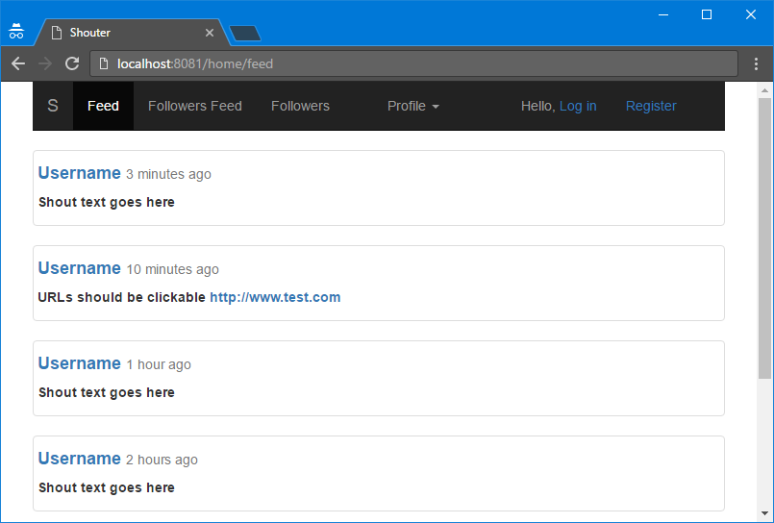

## Registration

Any user can register in the application by providing valid:

* **Username** - only alphanumeric characters are allowed and must be unique
* **Email** – must contain @ symbol and must be unique
* **Password** – must be at least 3 symbols long
* **Confirm password** – must be the same as the password
* **Birth date** – the user must be at least 13 years old to register successfully

When the user register may now log in. If he is not registered, he should have only access to the feed page to read the shouts of others users but cannot post any.

## Login

User can successfully log in by providing valid **username or email and password**. When the user is logged in successfully he now has access to

* **Feed page** where he can now post shouts as well as read shouts of all other users
* **Followers page** where he can see list of all users and follow or unfollow them, as well as search a given user by its username or part of it
* **Followers feed page** where he can see only the shouts of the users he followed
* **My Feed page** where he can see all of his shouts with option to delete any of them
* **Following you page** where he can see a list of all people who are following him
* **Profile page of any user** – the profile page of a user contains list of his shouts and an option to follow/unfollow him

If user tries to open any of those pages and he is **not logged in**, he should be **redirected to the login page**.

## Publish Shout

Shout is just a simple text no longer than 160 symbols. It might contain hyperlinks. Hyperlinks are any word that start with **http://**, **https://** or **www.**

That hyperlink must be able to redirect to the provided URL address when is clicked in the browser.

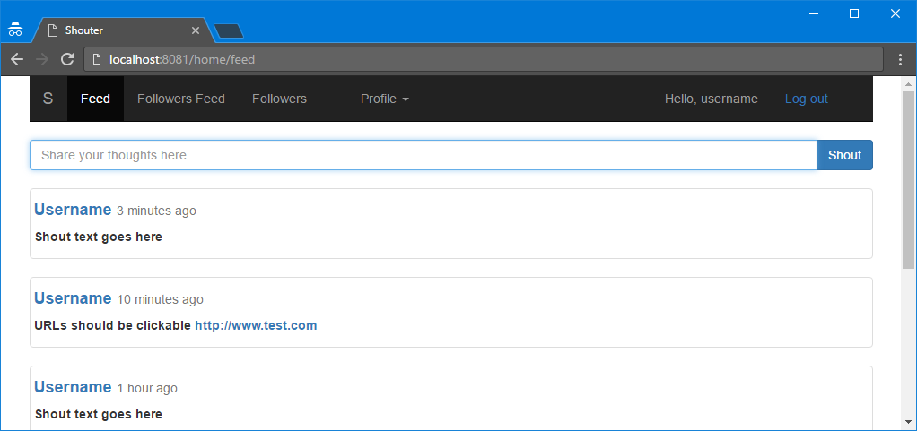

## Feed

Feed page contains a list of **all published shouts** ordered by time of publishing where the **most recent shouts are placed on the top**. Each shout should contain

* The **username** of the user who posted it as well as **link to his profile**
* **Relative time** of the shout
* The **shout text** itself

You can use the table below to help you with determining the relative time and how should be visualized

|  |  |
| --- | --- |
| **Time of posting shout relative to current time** | **Relative time** |
| < 1 second | less than a second |
| < 1 minute | less than a minute |
| < 1 hour (x minutes) | {x} minutes ago |
| < 1 day (x hours) | {x} hours ago |
| < 1 month (x days) | {x} days ago |
| < 1 year (x months) | {x} months ago |
| > 1 year | more than a year |





## Profile Page

The profile page of any user should contain his username, option to be followed or unfollowed and list of his shouts.

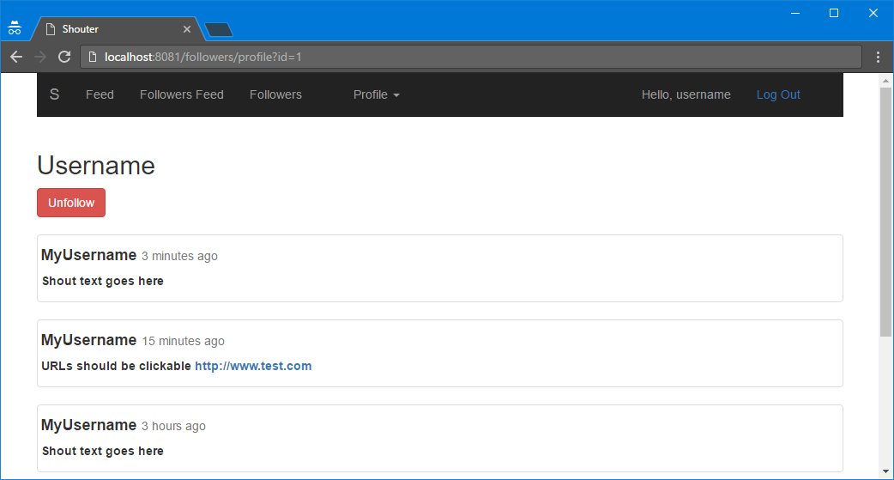

## Followers

The followers page has several features:

* the user can see a list of **all users** and **links** to their profiles
* option to **follow** or **unfollow** given user
* **search for users** by their username or part of it

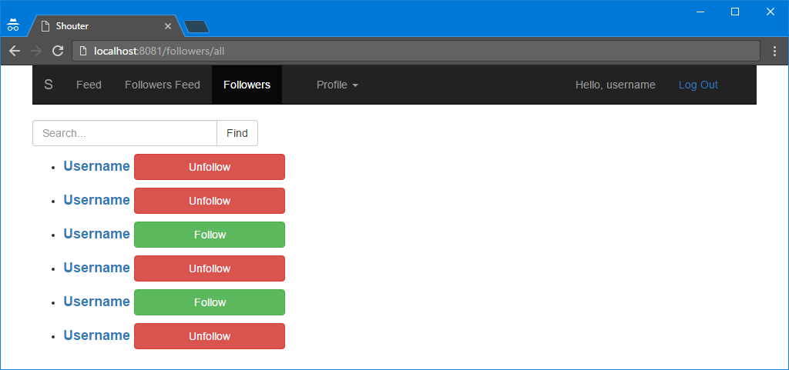

## Followers Feed

The followers feed has the same features as the main feed page but here the user see only shouts from users who the user decided to follow. And **has no option to post shout** from that page.

## My Feed

On the My Feed page, the use can see a **list of all of his shouts** with option to **delete** any of them.

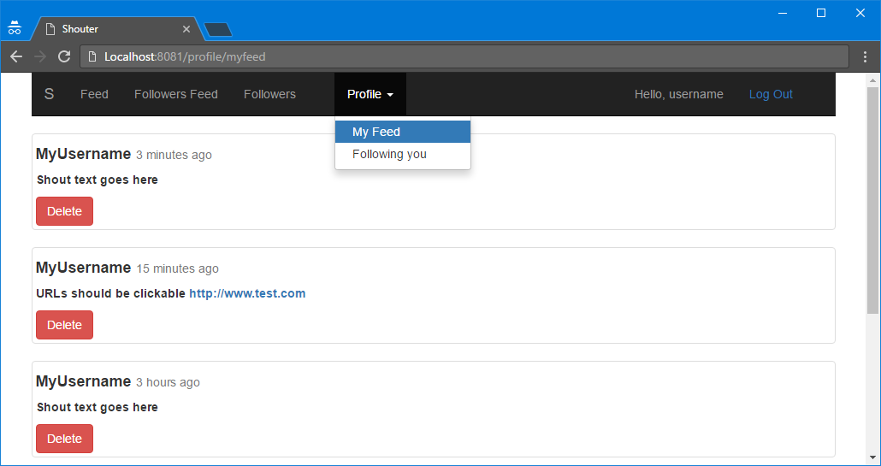

## Following You Page

On the **Following you** page the user can see a list of the usernames of **all users who followed him** and also **links** to their profiles.

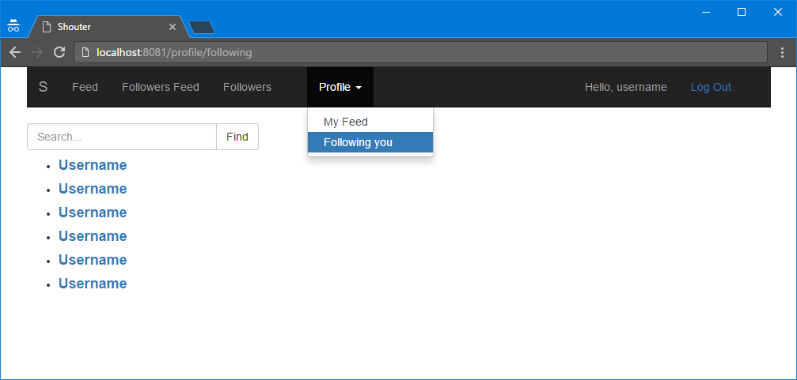

## Shout Expiration

Add option when publishing a shout to add expiration time **1 hour** or **1 day**. When that period expires, the shout should **delete by itself** and no longer should be displayed anywhere.

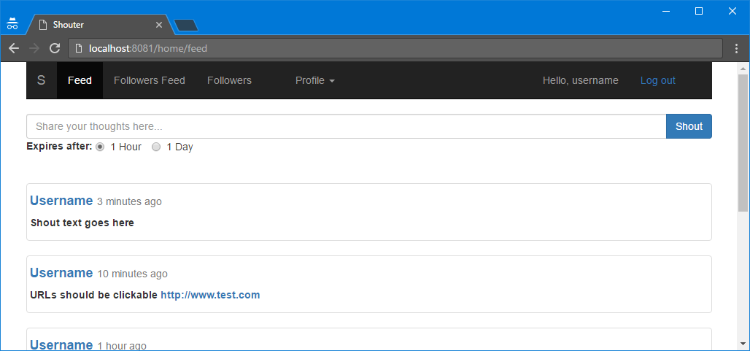

## Notifications

Any time some of the users **post a shout** all of **his followers should be notified** about that. A user can see all of his notifications in one page. They are ordered in a list. The most **recent** notifications should be **on the top** of the list.

